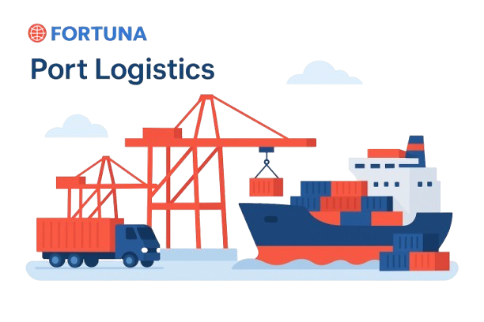

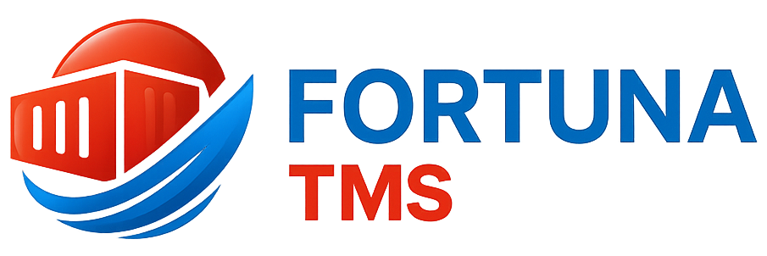

Website: www.fortunaglobalsupplychain.com
E-mail: info@fortunaglobalsupplychain.com

🏢 Company Overview

Fortuna Global Supply Chain Systems is a next-generation enterprise technology company revolutionizing the global logistics and supply chain landscape.
With a vision to create intelligent, transparent, and connected ecosystems, Fortuna blends innovation, data intelligence, and automation to help businesses achieve supply chain excellence.
Established with the belief that efficiency is the new currency, Fortuna empowers organizations to manage operations smarter — from demand planning to last-mile delivery — through real-time insights and seamless digital integration.
We are not just a technology provider; we are partners in transformation — driving global supply chain optimization with precision, performance, and predictive intelligence.

FORTUNA GLOBAL SUPPLY CHAIN SYSTEMS

“The Future of Enterprise Intelligence.”

Fortuna TMS Overview

“Fortuna -TMS” is an intelligent, cloud-based transportation management platform designed to revolutionize logistics and freight operations.
It streamlines planning, dispatch, tracking, and delivery management through automation, real-time data, and predictive analytics.
By connecting vehicles, routes, drivers, and cargo within a unified digital environment,

Fortuna TMS empowers enterprises to:
- Improve delivery accuracy,
- Optimize fleet performance, and
- Reduce operational costs through AI-driven decision-making.
“Fortuna TMS transforms logistics into intelligent motion — connecting every route, truck, and delivery with purpose.”

⚙️ 2. System Architecture
“Fortuna SIMS” operates on a 3-layer architecture:
- Application Layer – Business logic, workflows, dashboards
- Intelligence Layer – AI forecasting, analytics, automation
- Infrastructure Layer – Cloud platform, data storage, IoT device sync
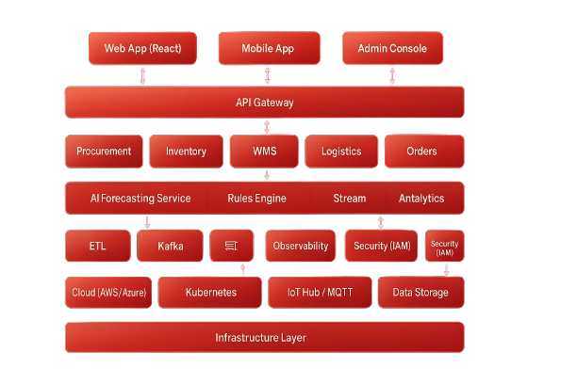

⚙️ Technology Framework
“Fortuna -TMS” is built on the Fortuna Intelligent Cloud Framework, combining:
1️⃣ AI Layer – Predictive analytics, route optimization, performance insights
2️⃣ IoT Layer – Real-time vehicle tracking, sensor-based alerts, telematics
3️⃣ Cloud Layer – SaaS-based multi-tenant system ensuring scalability and 24/7 availability

Architecture Model:
→ Cloud Infrastructure (AWS / Azure)
→ Data Intelligence Layer (AI & Machine Learning)
→ Application Layer (User dashboards, Driver app, Control tower)

+++

⚙️ Framework Architecture

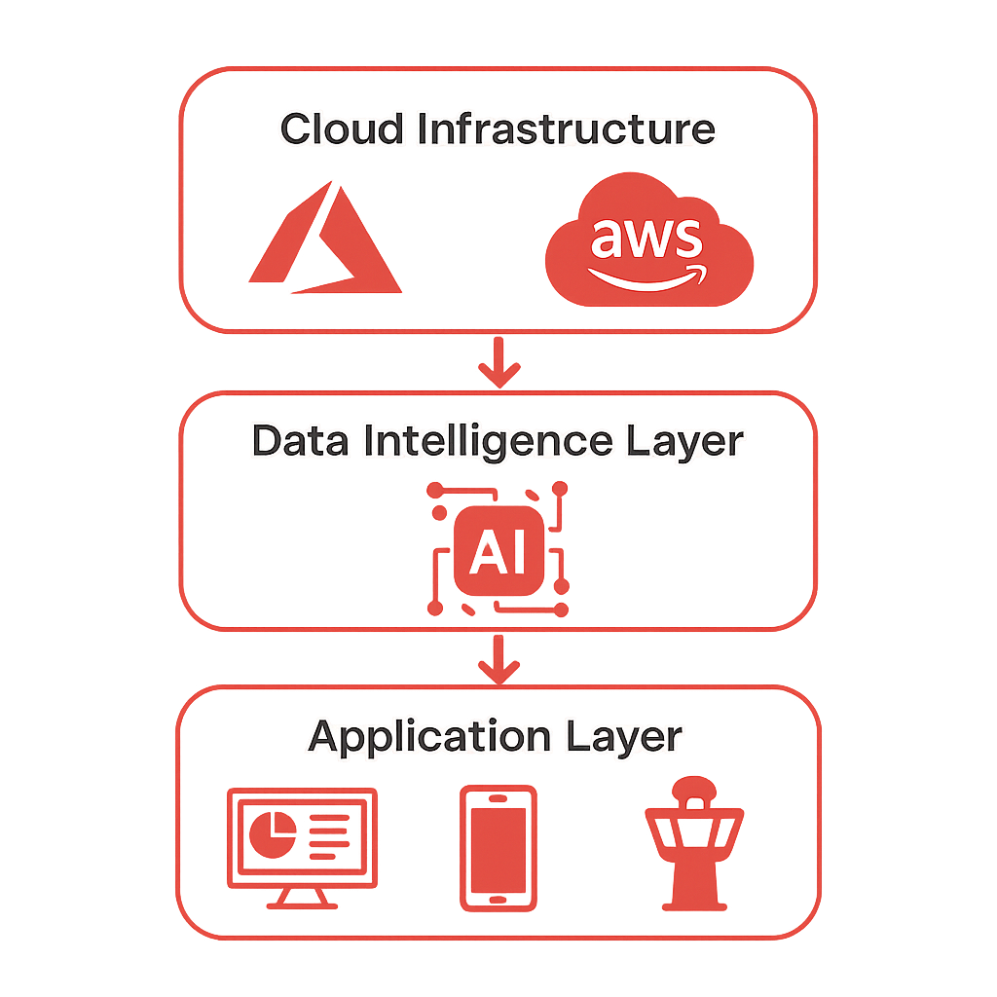

🚛 Module 1: Fleet Management

Product Modules, Sub-Modules & Operational Functionality

📚 Submodules:
- Vehicle Master & Registration
- Maintenance & Service Scheduling
- Fuel Usage & Cost Analytics
- Driver Management
- Vehicle Health Monitoring via IoT

⚙️ Operational Functionality:
- Register vehicles with complete technical details and life-cycle history.
- Schedule preventive maintenance and receive AI alerts for upcoming services.
- Track fuel consumption patterns and detect anomalies (IoT-based fuel sensors).
- Manage driver rosters, performance, and license validity.
- Monitor vehicle conditions (temperature, engine, tire pressure) in real time.

🗺️ Module 2: Route Planning & Optimization

📚 Submodules:
- Route Database Management
- AI Route Optimization Engine
- Traffic & Distance Analysis
- ETA Prediction System
- Route Deviation Alerts

⚙️ Operational Functionality:
- Create and manage dynamic routes for each region or destination.
- Use AI algorithms to calculate the shortest or fastest path.
- Integrate with Google Maps, GPS, and telematics devices.
- Predict ETA automatically and update in real-time based on movement.
- Generate instant alerts for deviation or unexpected halts.

📦 Module 3: Dispatch & Delivery Management

📚 Submodules:
- Shipment Creation & Scheduling
- Load Allocation & Vehicle Assignment
- Trip Sheet Generation
- e-POD (Electronic Proof of Delivery)
- Exception Handling & Alerts

⚙️ Operational Functionality:
- Automate dispatch creation from customer orders.
- Allocate vehicles and drivers based on load type and capacity.
- Digitally record loading/unloading operations.
- Capture proof of delivery with signature, photo, or QR scan.
- Receive automatic delay or exception alerts through IoT tracking.

💰 Module 4: Freight & Carrier Management

📚 Submodules:
- Freight Rate Contract Management
- Carrier Selection & Tendering
- Freight Billing & Payment Tracking
- Multi-Carrier Performance Dashboard

⚙️ Operational Functionality:
- Manage freight rate contracts across multiple carriers and lanes.
- Automate freight cost allocation and billing validation.
- Track carrier performance KPIs such as delivery punctuality and SLA adherence.
- Generate cost comparison reports between carriers.

📊 Module 5: AI Analytics & Reporting Engine

📚 Submodules:
- Dashboard Builder (Custom KPIs)
- Predictive Maintenance Analytics
- Route & Delivery Performance Reports
- Cost Efficiency Analysis
- Carbon Emission Tracking

⚙️ Operational Functionality:
- Build and customize BI dashboards for logistics and operations.
- Predict vehicle maintenance needs using data trends.
- Identify cost-saving opportunities using comparative analytics.
- Visualize delivery efficiency and on-time performance across regions.
- Measure environmental impact and sustainability KPIs.

⚙️ Module 6: Integration & Communication Layer

📚 Submodules:
- API & Web Service Integration
- ERP / SIMS Connectivity
- GPS Device Communication Layer
- SMS & Email Notification Center

⚙️ Operational Functionality:
- Connect with external ERPs (SAP, Tally, SIMS) for seamless order flow.
- Integrate real-time GPS and IoT feeds into a unified dashboard.
- Enable automated alerts for customers and internal teams.
- Create event-based workflows (e.g., “Dispatch → Customer SMS → ETA Update”).

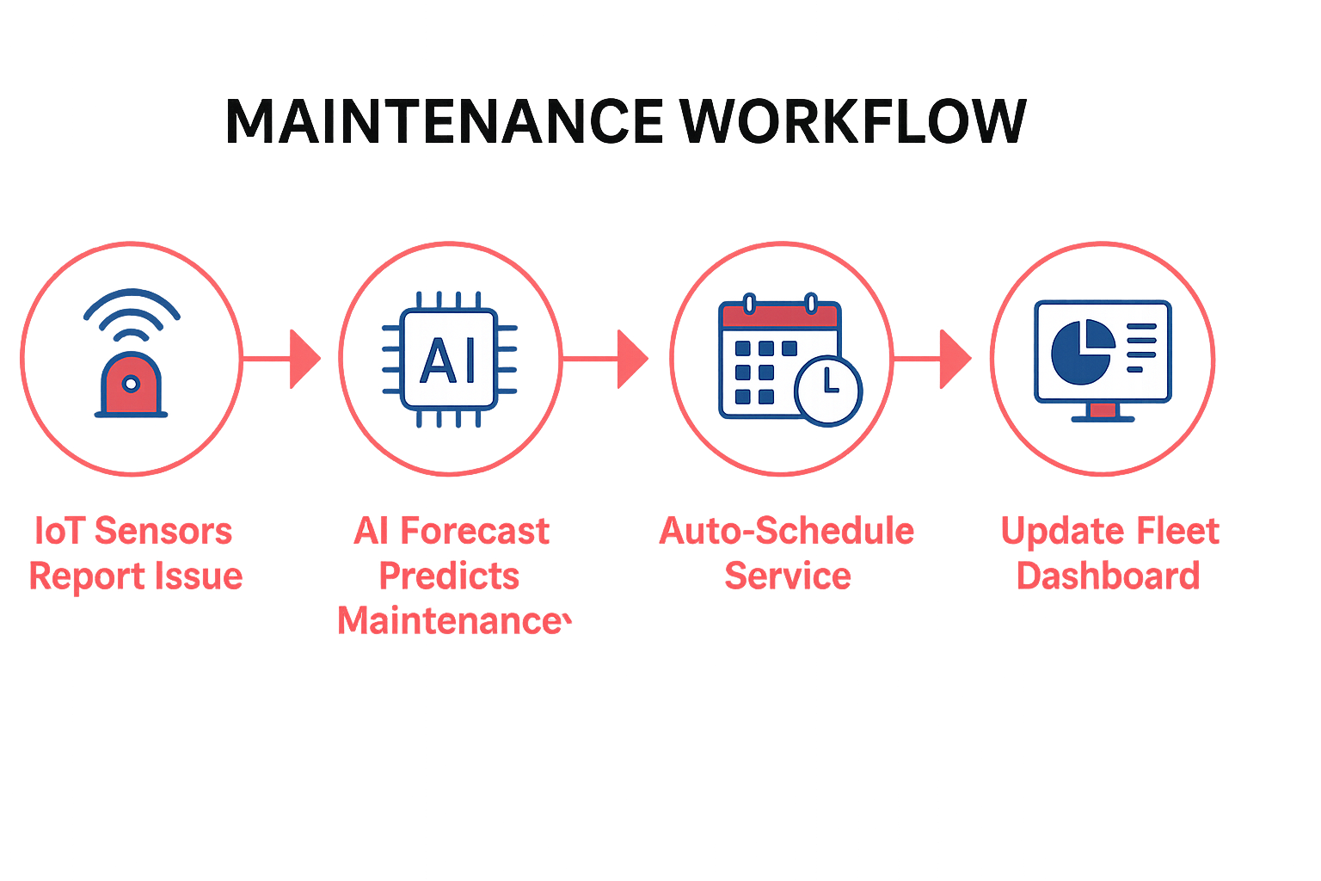


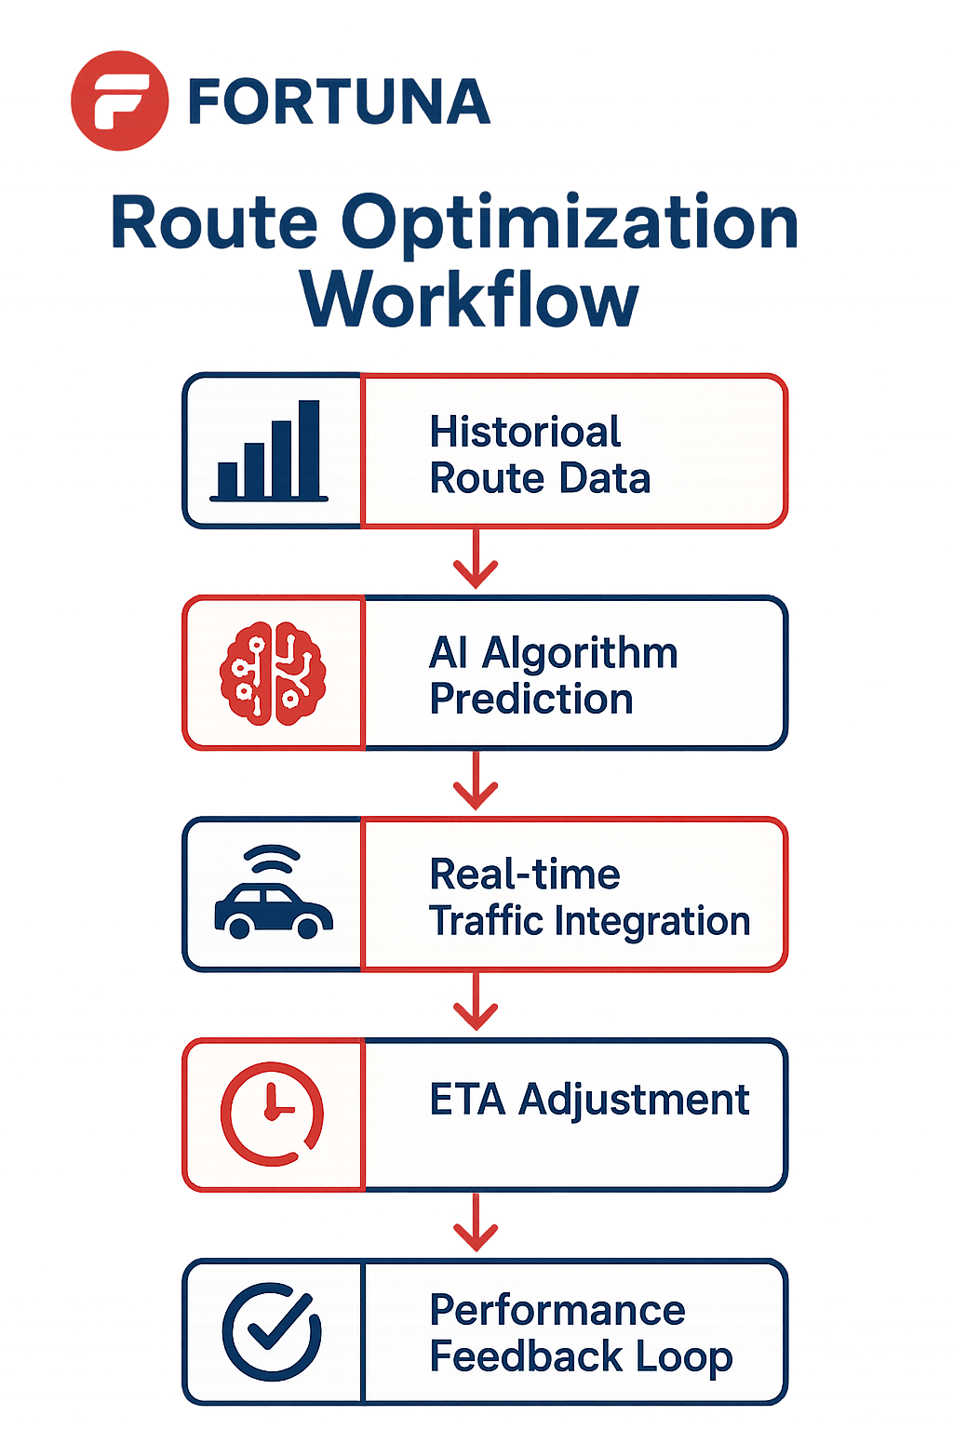

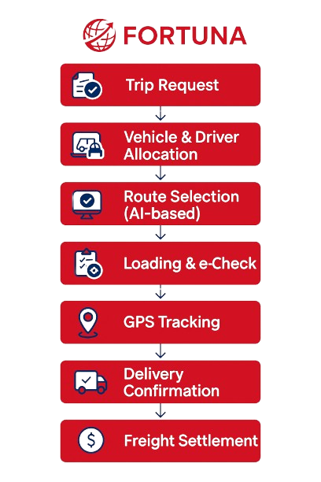

⚙️ Functional Work Flows

⚙️ Technology & Infrastructure

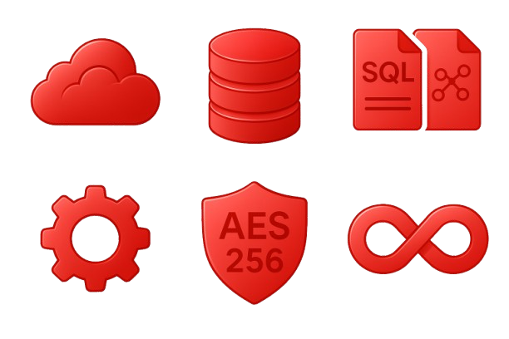


- Security: AES 256-bit encryption, role-based authentication, audit trails.

- Integration: REST APIs, Webhooks, MQTT (for IoT sync).





- Database: PostgreSQL + NoSQL Hybrid.

- Cloud: Multi-tenant, scalable SaaS model (AWS/Azure/GCP).


- Frontend: React JS (Fortuna theme-based UI).

- Backend: Node.js / Python micro services architecture.

Fortuna TMS Advantages
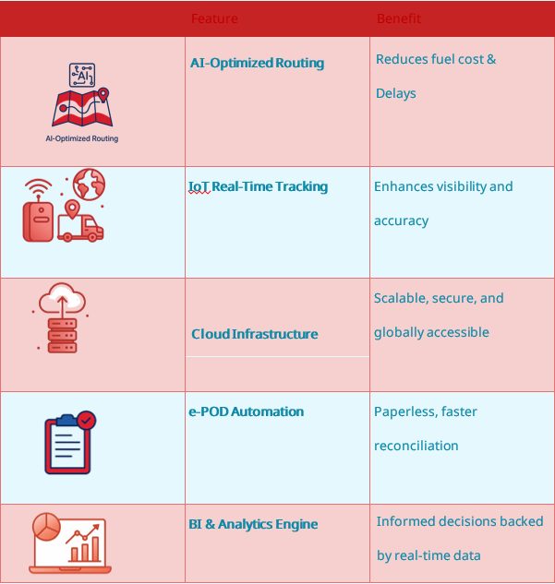

🚀 Operational Benefits
- 35% improvement in route efficiency
- 30% fuel cost savings
- 25% reduction in delivery delays
- 20% increase in fleet utilization
- Real-time visibility across all routes & vehicles

🌐 The Fortuna Philosophy

“Fortuna TMS connects intelligence to movement.
Every delivery, every route, and every kilometre becomes smarter, faster, and more reliable.”

Automotive & Industrial Manufacturing

🏭 Industries Served


FGSCM - supports the automotive sector with advanced logistics planning, vendor coordination, and predictive maintenance scheduling. From global parts movement to plant-level production support, our systems reduce lead times and enhance supply chain agility

Ports & Logistics
•


Fortuna supports the automotive sector with advanced logistics planning, vendor coordination, and predictive maintenance scheduling. From global parts movement to plant-level production support, our systems reduce lead times and enhance supply chain agility

Food & Beverage Distribution
•

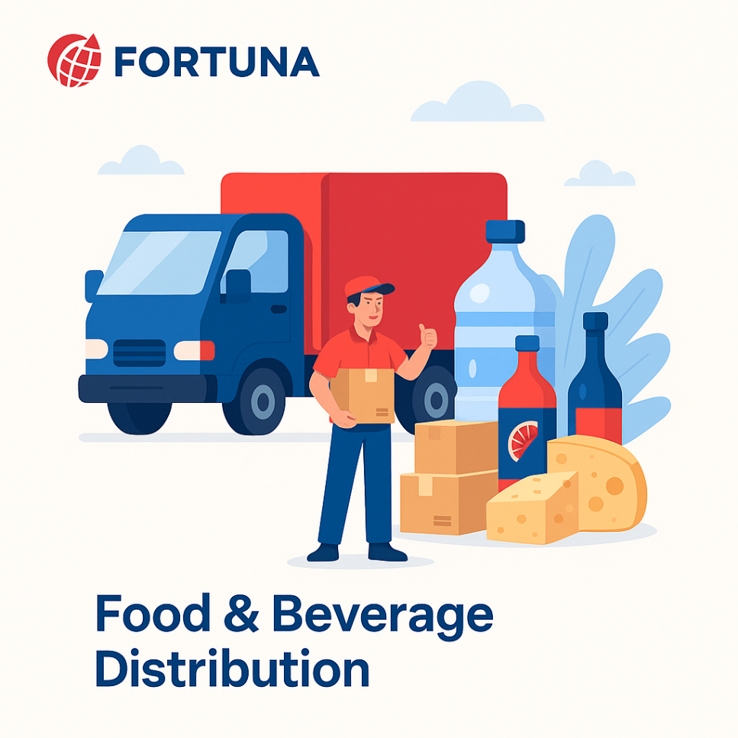
Freshness and safety are at the heart of Food & Beverage -supply chains. We enable end-to-end visibility with IoT-driven tracking, automated quality checks, and predictive demand planning—ensuring traceability from farm to fork.

Fashion & Retail Industry
•


With High seasonal demand & agile supply chain Planning, Fortuna will empowers retailers with faster replenishment & reduces stock outs

Pharma & Healthcare
•


Medical safety and regulatory compliance are non-negotiable. We provide automated solutions for cold chain logistics, product traceability, and compliance monitoring—ensuring life-saving medicines and healthcare products reach destinations safely and efficiently.

E-Commerce & Distributional Channels
•

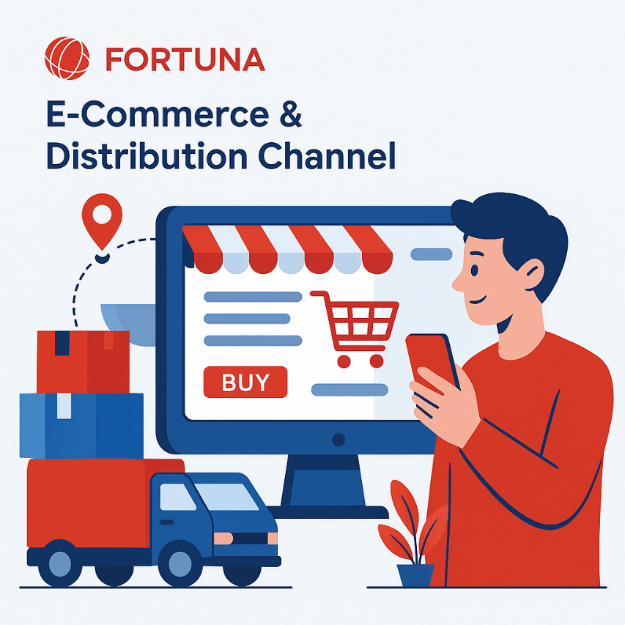
In a fast-moving E-Com world, speed and efficiency are critical. Our platforms enable automated order management, demand forecasting, and last-mile delivery optimization—ensuring customers receive the right products, at the right time, every time.

🏛️ Corporate Identity

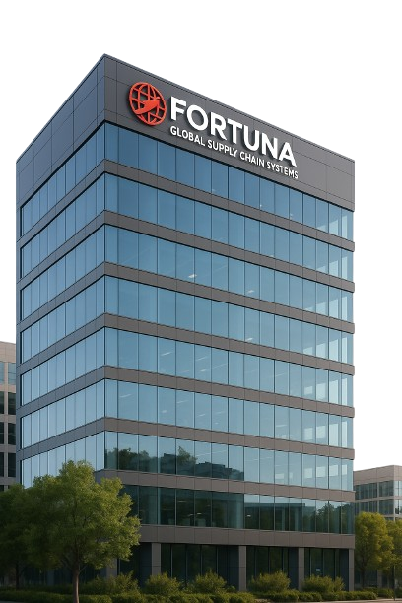
Headquarters: Visakhapatnam, Andhra Pradesh, India
Website: www.fortunaglobalsupplychain.com
Email: info@fortunaglobalsupplychain.com

